CODEM BOOTCAMP TASK
WEEK – 1
JAVASCRIPT EXERCISES

SUBMITED BY
Vasundhara P S
IT – III Year

GITHUB LINK : https://github.com/vasujoe2005/CodemBootCamp.git

Task 1: Console Information Program Requirements
- Create variables to store:
  - full name (string)
  - email ID (string)
  - current year (number)
- Create at least two numeric variables.
- Perform at least five different mathematical operations using those numbers
- Display all personal details using console.log().
- Display the result of each mathematical operation using console.log() with clear labels.

Program:
//Personal Details
let fullName="Vasundhara P S";
let emailID="2315028@nec.edu.in";
let currentYear=2026;
console.log("Full Name:",fullName);
console.log("Email ID:",emailID);
console.log("Current Year:",currentYear);
//Mathematical Operations
let a=7;
let b=3;
console.log("Addition:",a+b);
console.log("Subtraction:",a-b);
console.log("Multiplication:",a*b);
console.log("Division:",a/b);
console.log("Modulus:",a%b);

Output:
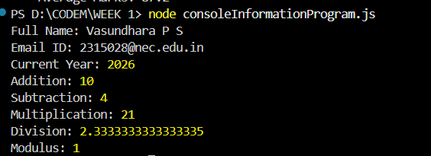

Task 2: Arithmetic Operations Program Requirements
- Create two numeric variables.
- Perform the following operations:
  - addition
  - subtraction
  - multiplication
  - division
  - modulus
  - power
- Store each operation result in a separate variable.
- Log each result to the console with a meaningful description.

Program:
//initailise values
let x=7;
let y=3;
//Arithimetic operations calculations
let add=x+y;
let sub=x-y;
let mul=x*y;
let div=x/y;
let mod=x%y;
let power=x**y;
//Display
console.log("Addition:",add);
console.log("Subtraction:",sub);
console.log("Multiplication:",mul);
console.log("Division:",div);
console.log("Modulus:",mod);
console.log("Power:",power);

Output:
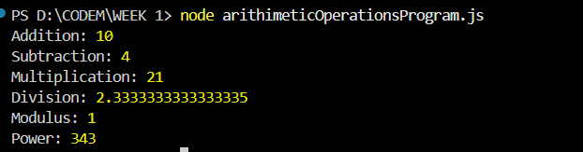

Task 3: Simple Interest Calculator Requirements
- Create variables for:
  - principal amount (number)
  - rate of interest (number)
  - time period (number)
- Calculate simple interest using the formula:
  - (principal * rate * time) / 100
- Store the calculated interest in a variable.
- Display the final result using console.log() in sentence format.

Program:
//SI(Simple Interest) Calculator
let principal=10000;
let rate=10;
let time=2;
let si=(principal*rate*time)/100;
console.log("SI:" + si);
Output:


Task 4: String Processing Program Requirements
- Create a variable to store a full name (string).
- Convert the string to uppercase and store the result.
- Convert the string to lowercase and store the result.
- Find and store the length of the string.
- Extract the first name from the full name.
- Log all results individually using console.log() with proper labels.

Program:
//initialise
let fullName="Vasundhara P S";
//String Operations
let upperCaseName=fullName.toUpperCase();
let lowerCaseName=fullName.toLowerCase();
let nameLength=fullName.length;
let firstName=fullName.split(" ")[0];
//Display
console.log("Original Name:",fullName);
console.log("Uppercase:",upperCaseName);
console.log("Lowercase:",lowerCaseName);
console.log("Length:",nameLength);
console.log("First Name:",firstName);

Output:
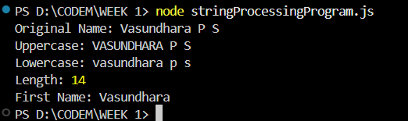

Task 5: Template Literal Output Program Requirements
- Create variables to store:
  - name (string)
  - role (string)
  - organization or company name (string)
- Use template literals to generate a formatted introduction message.
- Display the generated message using console.log().

Program:
//initialise
let name="Vasundhara P S";
let role="IT Student";
let organisation="NEC Kovilpatti";
//use of template literal
let message=`Greetings all, I am ${name}.My role is an ${role} at ${organisation}.`;
//print output
console.log(message);

Output:

Task 6: Variable Behavior Program Requirements
- Declare one variable using var.
- Declare one variable using let.
- Declare one variable using const.
- Attempt to reassign values to each variable.
- Attempt redeclaration where applicable.
- Log the results to the console.
- Add comments explaining the observed behavior.

Program:
//Declaration
var a=10;
let b=20;
const c=30;
console.log("var a =",a);
console.log("let b =",b);
console.log("const c =",c);
//Reassignment
a=100;
b=200;
// c=300; // TypeError Occurs
console.log("\nAfter Reassignment:");
console.log("var a =",a);
console.log("let b =",b);
console.log("const c =",c);
//Observation: var and let allows reassignment.
//const does not allow reassignment.
//Redeclaration
var a=5000;
// let b=6000; //SyantaxError
// const c=7000; //SyantaxError
console.log("\nAfter Redeclaration:");
console.log("var a =",a);
console.log("let b =",b);
console.log("const c =",c);
//Observation: var allows redeclaration but let and const does not
Output:

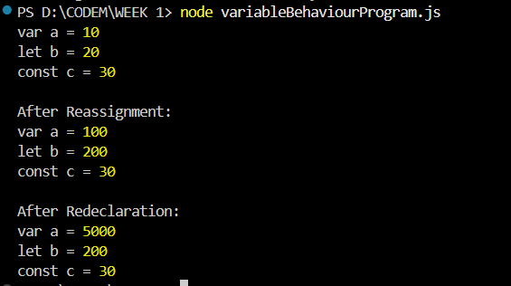
Task 7: HTML and JavaScript Integration Requirements
- Create a basic HTML file.
- Create an external JavaScript file.
- Link the JavaScript file to the HTML file.
- Use JavaScript to log a message when the page loads.
- Display the message using console.log().

index.html(HTML File):
<!DOCTYPE html>
<html lang="en">
<head>
<meta charset="UTF-8">
<title>HTML and JavaScript Integration</title>
</head>
<body></body>
<h1>HTML & JavaScript Integration Task</h1>
<script src="script.js"></script>
</body>
</html>
script.js:
window.onload = function() {
console.log("The page has loaded successfully!");
};

Output:

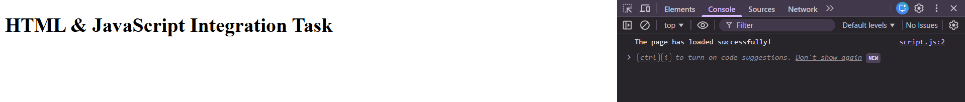

Task 8: Student Marks Calculation Program Requirements
- Create variables to store marks of five subjects.
- Calculate the total marks and store the result.
- Calculate the average marks and store the result.
- Display total and average using template literals.
- Log the output to the console.

Program:

//initalisation
let math=85;
let science=90;
let english=78;
let social=88;
let computer=95;
let total=math+science+english+social+computer;
let average=total/5;
console.log(`Total Marks:${total}`);
console.log(`Average Marks:${average}`);

Output:
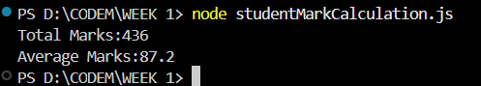

Task 9: Email String Analyzer Program Requirements
- Create a variable to store an email address.
- Extract the username part from the email.
- Extract the domain name from the email.
- Store both values in separate variables.
- Log the username and domain separately using console.log().

Program:

let email="2315028@nec.edu.in";
let username=email.substring(0, email.indexOf("@"));
let domain=email.substring(email.indexOf("@")+1);
console.log("Username:",username);
console.log("Domain:",domain);
Output:
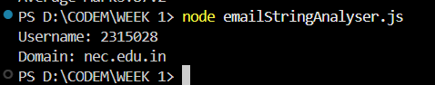

Task 10: JavaScript Utility Program (Programming Mandatory) Requirements
- Create variables to store:
  - user name (string)
  - age (number)
  - marks of five subjects (numbers)
- Calculate total marks.
- Calculate average marks.
- Convert the user name to uppercase.
- Find the length of the user name.
- Display all calculated and processed values using template literals and
- Log the final output using console.log().

Program:
//initialise
let userName="Vasundhara P S";
let age=20;
let math=85;
let science=90;
let english=78;
let social=88;
let computer=95;
let totalMarks=math+science+english+social+computer;
let averageMarks=totalMarks/5;
let upperCaseName=userName.toUpperCase();
let nameLength=userName.length;
let finalOutput=`
User Name: ${userName}
User Name (Uppercase): ${upperCaseName}
Name Length: ${nameLength}
Age: ${age}
Marks:
Math: ${math}
Science: ${science}
English: ${english}
Social: ${social}
Computer: ${computer}
Total Marks: ${totalMarks}
Average Marks: ${averageMarks}`;
console.log(finalOutput);

Output:
